Canadian Art
Name:
Institutional Affiliation:

Canadian art is the visual and plastic art, which originates from the contemporary Canada. The art has its influence from the First Nations Peoples and after that the emigrants that included craftsmen from Europe and later by the artists from other countries in the world. The Canadian art has a reflection of these different origins since artist embraced these propensities. The paper will focus on artists with collective and community care in their pieces.
Viva Kitchen Art Auction festival started as a feeding tool for the audience and artists at the first iteration of the event in 2006. None who attends the celebration would go hungry, and still, there is more to meet their physical needs. Also, the meal prices range from 7-10 dollars, which cheap to subsides the free entrance (Berson, 2019). In 2017, two renowned artists from Montreal and Sarajevo, Sonja Zlatanova and Andreja Dugandžic, cared for the kitchen. The two craftsmen concentrated on gendered cooking practices that year. Their sentiments came across as cooks and feeders, who give love through food and pain as well. As a team, they came up with a menu, which is rooted in Balkan spirit. It had the language of loss, abandonment, love and feminized body. Well, food is a basic need and consuming it is primal and providing for is caring and nurturing.
Secondly, Ting Chak, an artist who cares and most of the questions concerning care are notable in his works. Chak studied architecture, and most of her themes revolve around guaranteeing care for everybody and evaluating matters regarding spatial justice. In 2016, Chak studied the public and private realm’s liminal space for the immigrant domestic laborers at suitable Accommodation event. The occasion took place in Hong Kong at the Central Oasis Gallery. Most of the workers leave the homes they live and work in early on their day off because of insufficient space and the possibility that they might do unpaid labour on that day. The domestic workers gather in plazas and public parks to sleep, do pedicures and manicures on their own, and to organize themselves. However, grooming is a ritual to the Hong Kong residents. Consequently, Chak mapped the labourers private living space in a scale of 1:1 masking tape drawings with testimonials of their working and living conditions. She unveils the suitable accommodation paradoxes and proving that caring and being cared for stay precarious when pervasive space and self-negotiation are under neoliberalism (Berson, 2019).
Thirdly, there is Jessica Karuhanga who features other artists in her projects to build trust that comes with experience. The Canadian artist focus on video and installation. Her art revolves around choreography and gesture rubbishing the stereotypical desire for the black body as a source of entertainment. Karuhanga enables other artists with an artistic agency and developing a shared space. The videos have contents of the blackness geopolitics and her consequential meditations. Pieces like 2014’s A Still Cling to Fading Blossoms challenge depicting the black population in Canada while showing the black grief and coming with a possible solution. In another art, Karuhanga puts herself in a cultural canon. Sincerely, she opens the audience’s eyes on the Great White North image of the missing black female body. The artists play with gospel and blue aesthetic to get into the Canadian landscape showing her presence in community building (Berson, 2019).
In 2015, Yen-Chao Lin, Kate Whiteway, Thy Anne Chu Quang, and Hera Chan founded the Atelier Céladon. The organization endevors to undermine the contemporary art through posing a legal organization while in real sense organizing events minimal communication output. An event of sorts took place in Montreal in 2016. It was called “A Glass House Should Hold No Terrors,” and it took place in a deserted hospital. Céladon is a transparent glaze color, which comes from china with cracks that are tiny and bake-in. The metaphor is bringing the non-west outlook to the world of art through operating and creating in these cracks (Berson, 2019). The members of this group range from writers to activists. The group care more about skill sharing and developing a surrounding of care as opposed to the production of art.
In conclusion, the artists mention above used the collective and community theme differently. Sarajevo, Sonja Zlatanova and Andreja Dugandžic, cared for the kitchen in 2017 at Viva Kitchen Art Auction festival. As a team, they came up with a menu, which is rooted in Balkan spirit. It had the language of loss, abandonment, love and feminized body. Chak thinks the suitable accommodation paradoxes and proving that caring and being cared for stay precarious when pervasive space and self-negotiation are under neoliberalism. Jessica Karuhanga shares the the misguided views of the black females in Canada. Lastly, Atelier Céladon care more about skill sharing and developing a surrounding of care as opposed to the production of art.

Images 1
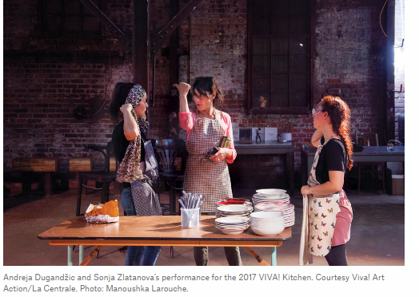
Image 2
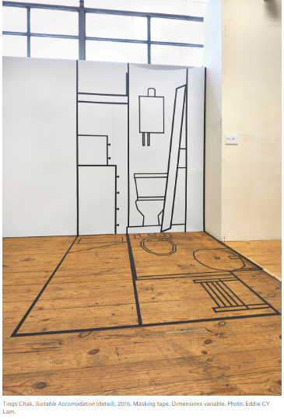
Image 3
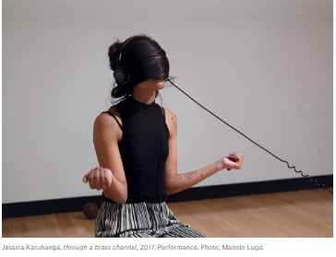

Image 4
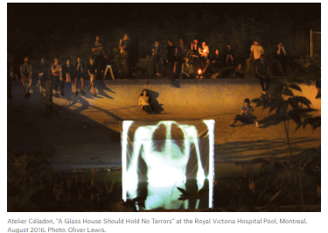

Reference
Berson, A. (2019, October 3). 10 Artists Who Are Taking Care. Retrieved from Canadianart: https://canadianart.no-media.co/articles/taking-care/

